Daniel Stoy – 25%

Steven Hagedorn – 25%

Henry Bish – 25%

Jakob Wardega – 25%

Task 1:

We made a vector of linked lists. Each entry within the vector is a point identified by its value. Each connection of the linked list is considered an edge. We made it so all edges are non-directional. This can be seen in the fact that if you have a connection from one point to another there will also be a connection from the second point to the first.

Shows adding edges works

After adding edges, an edge may be found or removed.

After adding edges, removing or looking for (finding) an invalid edge does nothing.

After adding edges, finding out edges for a valid vertex returns number of edges. For an invalid vertex it throws an error and exits the program.

After adding edges, finding in edges for a valid vertex returns number of edges. For an invalid vertex it throws an error and exits the program.

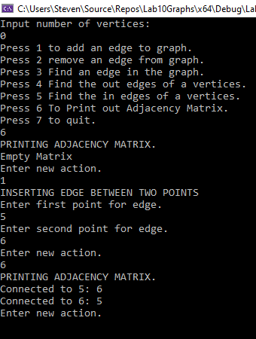

Printing an empty or filled matrix works.